Update Food Items

Document Information

|  |  |
| --- | --- |
| **Document Title** | Title of use case – Verb Noun phrasing is almost always the most appropriate! |
| **Document Owner** |  |
| **Version** |  |
| **Status** |  |
| **Date** |  |

1. Brief Description

This use case allows the school administrator to update food items by modifying their details such as price, dietary restrictions, allergies, and quantity limits.

1. Actors

* School Administrator

1. Trigger

The school administrator wants to update food items.

1. Pre-Conditions

* The school administrator must be logged into the system
* The food item must be existed.

1. Post-Conditions

* The food item details are updated and saved in the system.

1. Basic Flow
2. The school administrator selects the “Food item” menu.
3. The system displays Food Item page that displays food items available on the SLOS.
4. The school administrator selects the food item they want to update.
5. The system displays the current details of the selected food item.
6. The school administrator modifies the necessary details such as price, description, dietary restrictions, allergies, and quantity limits.
7. The school administrator select Save button to save the changes.
8. The system updates the food item details.
9. The system redirects to Food Item page.
10. Alternate Flows

* 2a: The school administrator can search for a specific food item by entering the name or a part of the name in the search box. Then continue step 3.

1. Exception Flows

* 2b: If there are no food items available, the system displays a message "No food items found.".
* 6a: If the school administrator enters invalid details or misses required details, the system displays an error message and prompts the school administrator to correct the input.
* 6b: If the system encounters an error while saving the changes, the system displays an error message and prompts the school administrator to try again.

1. Business Rules

* The food item name must be unique.
* The food item price must be a positive value.
* The quantity limit must be a positive value.
* Only the school administrator has the permission to update food items.

1. Non-Functional Requirements

* The system should be able to validate the input and add new food items quickly (1s-2s).

1. Supplemental Requirements
2. Visual Model

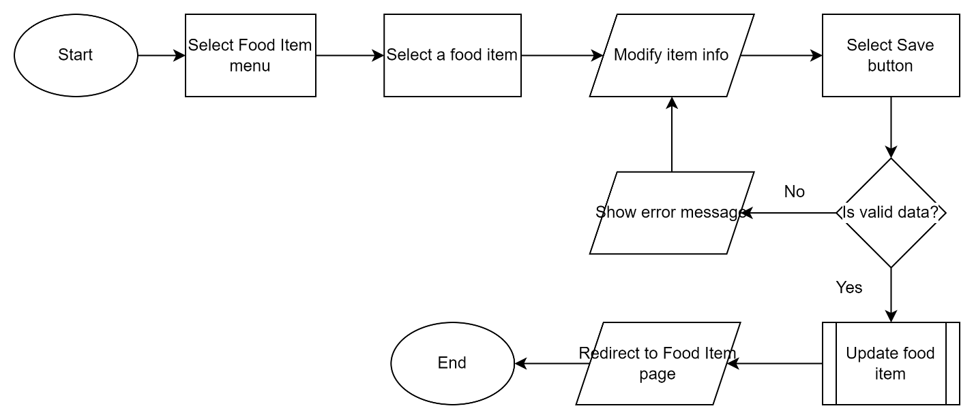

Revision History

|  |  |  |  |  |
| --- | --- | --- | --- | --- |
| V. | Date | Author | Description | Status |
|  |  |  |  |  |
|  |  |  |  |  |